

HIM/WHE/WHO

https://herams.org

June 2019

**HeRAMS Platform User’s Manual**

Table of Contents

1. Overview 3

1.1 Homepage & Login 3

2. The Dashboard 5

2.1 Overview 5

2.2 Infrastructure 6

2.3 Condition 6

2.4 Functionality 7

2.5 Accessibility 7

2.6 Management & Support 8

2.7 Basic Amenities 8

2.8 Service Availability 8

3. Filters 9

4. Projects & Workspaces 10

4.1 Managing Projects & Workspaces 10

4.2 HeRAMS Users’ roles 12

5. Additional Features 12

# Overview

HeRAMS stands for Health Resources and Services Availability Monitoring System. The HeRAMS is a collaborative approach, particularly designed to operate in highly constrained, low-resourced and fast changing environments, where access, security and the lack of time and resources impede the use of other assessment and monitoring approaches.

The purpose of this manual is to guide users on different steps to interact with herams.org platform, in terms of:

* Data entry/ update (Input)
* Data analysis- dashboards (output)

## **Homepage & Login**

To access HeRAMS IT-based Platform, on internet browser (preferable Firefox), type: <https://herams.org>

| **Step** | **Action** | **Result** |
| --- | --- | --- |
| 1 | When accessing the platform, a screen will pop up to prompt you entering your credentials (login and password) and get access to HeRAMS by clicking on “Login”, if you are an existing user.  If you forgot your password, you can click on Reset password button  If you are not a registered user, please Sign up first | ../../Screen%20Shot%202019-04-15%20at%2016.17.46.png |
| 2 | Complete the registration form and click on “Submit” |  |
| 3 | When login successfully, the home page will be loading to display the world map with HeRAMS projects. The left menu displays a list of all projects exist in the platform | ../../Screen%20Shot%202019-04-15%20at%2016.18.10.png |
| 4 | Click on one of the projects on the left menu or on the map to display (if data are available): an aggregated information is provided regarding:   * Name of the country * Number of assessed MoSDs[1] (i.e., health facilities) * Number of contributors * Type of MoSDs expressed in percentages and distinguished by Primary, Secondary, Tertiary, and others (i.e., Mobile Clinics) * The Functionality of these MoSDs, expressed in percentages and distinguished by Fully functional, Partially functional, Not functional * Service availability, expressed in percentages and distinguished by Fully available, Partially available, Not available, Not normally provided   Here Nigeria is an example | ../../Screen%20Shot%202019-04-15%20at%2018.29.24.png |

# The Dashboard

The following section illustrates the steps to be followed to login and interact with the platform’s dashboard, using HeRAMS Nigeria as an example:

1. If access is granted to Nigeria project, click on the **Details** button and you will be directed to HeRAMS Nigeria platform.
2. The production mode for HeRAMS Nigeria will be displayed, showing aggregated information as an overview for key information pillars, in addition to detailed information pillars on the left side menu, as follow:

* Overview
* Infrastructure
* Condition
* Functionality
* Accessibility
* Management & Support
* Basic amenities
* Service Availability

The dashboard composes of a list of pages and filters. Each page refers to a HeRAMS standard information pillar, as described in the following sections. Of note, all registered users for a certain project, can access its dashboards.

## **Overview**

The overview page displays an overall summary information, in form of:

* A map to spot the distribution and number of MoSDs (i.e., health facilities) by level of:
  + Secondary and Tertiary care: Hospital
  + Primary Health Care: Primary Health Care Centre, Health Clinic and Health Post
  + Camp and mobile clinic
* Donut charts to summarize different indicators, such as level of damage, functionality status, accessibility and service availability in the assessed MoSDs, which is country specific

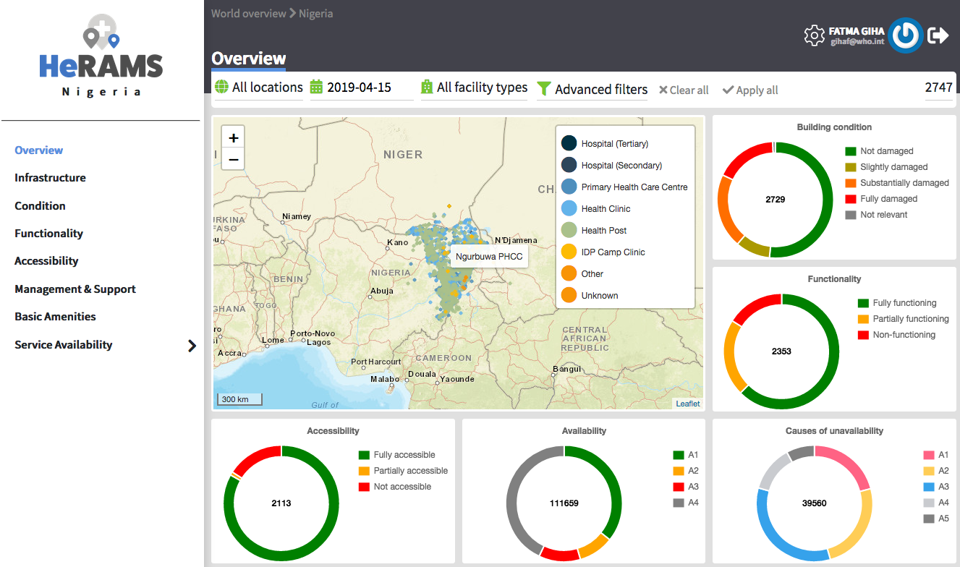

Of note:

* By clicking on any dot in the map the name of the health facility will appear.
* By moving over the mouse on the pie chart, the number and percent of the selected criteria (i.e., functionality) will appear.

## **Infrastructure**

The Infrastructure page, displays:

* Descriptive analysis:
* A map to spot the distribution and number of MoSDs (i.e., health facilities) per type
* A donut chart to illustrate MoSDs per type
* A donut chart to illustrate modality of the building structure (permanent or temporary)
* A table to illustrate reported accessibility barriers

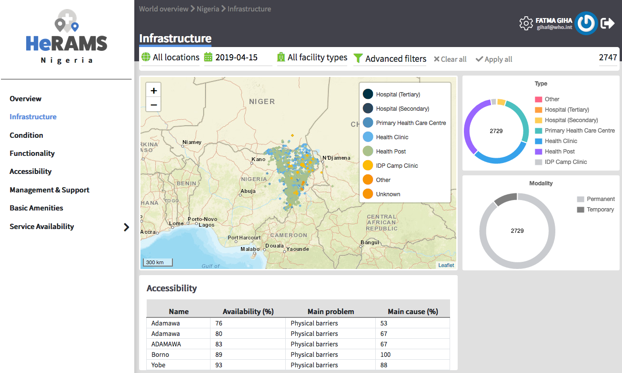

## **Condition**

The condition page displays the level of reported damage to the health facilities buildings following a standard classification and scale (Not Damaged to Fully Damaged). Information is visualised as:

* A map to spot the distribution and number of health facilities according to the level of damage condition
* Donut charts to summarize
  + - The reported level of building damage
    - The reported types of health facilities
* A table to provide the name of the prioritized localities in terms of damage and the main causes

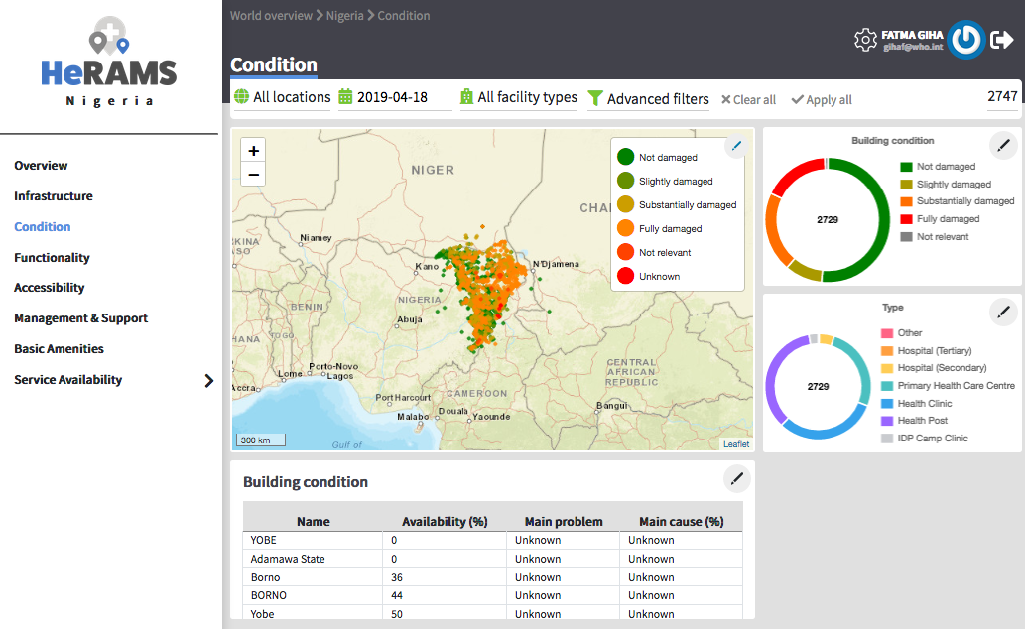

## **Functionality**

The functionality page displays the level of functionality status of the MoSDs following a standard classification and scale (Fully Functioning to Not Functioning), in terms of:

* A map to spot the distribution and number of MoSDs according to the functionality status
* Donut charts to summarize
  + - The level of functionality status per number of MoSDs
    - The reported causes of non-functionality per number of MoSDs
* A table displays the list of priority areas in terms of non-functional health facilities and reported causes.

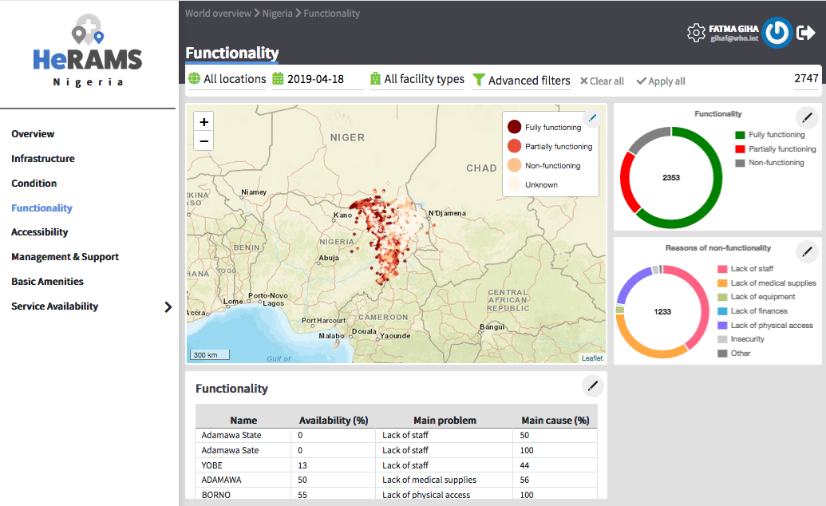

## **Accessibility**

The accessibility page displays the level of accessibility to the MoSDs following a standard classification and scale (Fully Accessible to Not Accessible), in the form of:

* A map to spot the distribution and number of MoSDs according to the accessibility status
* Donut charts to summarize
  + - The level of accessibility per number of MoSDs
    - The reported causes of inaccessibility per number of MoSDs
* A table displays the list of priority areas with inaccessible MoSDs and the main reported cause of inaccessibility

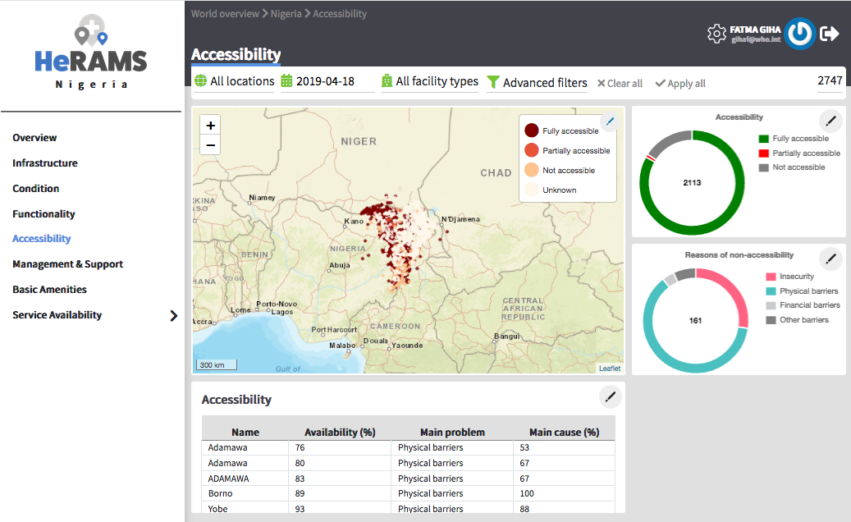

## **Management & Support**

The management & support page displays information on the management of the MoSDs and the level of provided support by partners, in terms of:

* Ownership:
* A map to spot the distribution of MoSDs according to their ownership (i.e., public, private, private-faith-based, NGO/iNGO)
* A donut chart to illustrate categories of ownership per number of MoSDs
* External support:
  + A donut chart to illustrate the level of provided support by partners

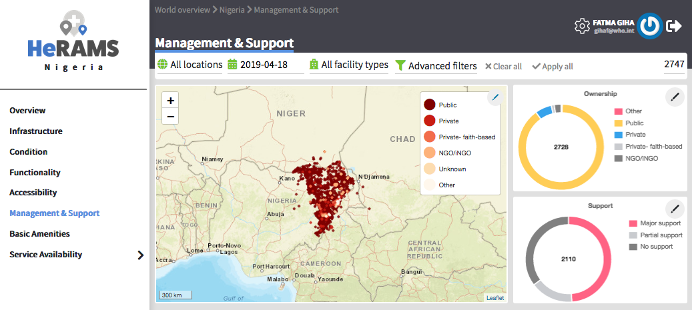

## **Basic Amenities**

The Basic Amenities page displays

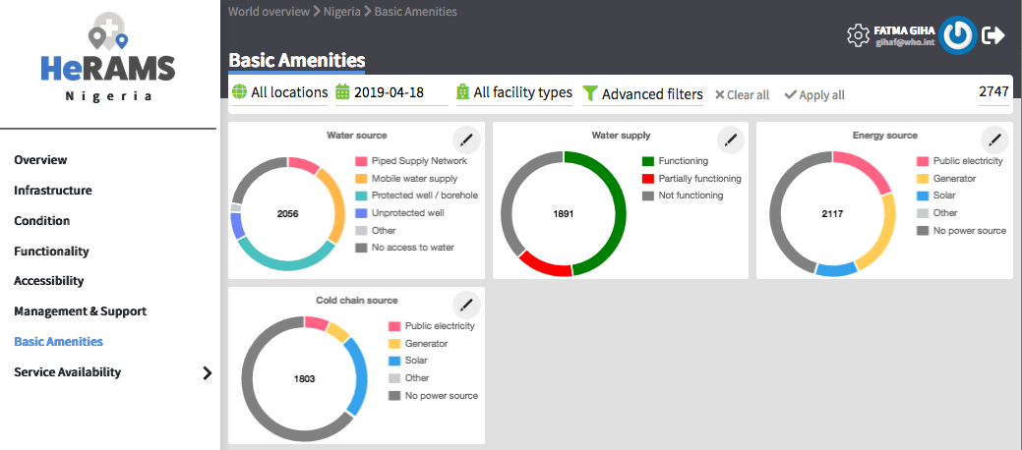

## **Service Availability**

The Service Availability page displays multiple pages per type of service, and each page displays:

* A map to spot the distribution of the MoSDs providing the selected health service
* Donut charts to summarize
* The level of service availability
* The underlying causes of unavailability of the service
* A table displays the list of priority areas per service unavailability and the main reported underlying cause

# Filters

Filtering of results could be done by applying one or all the following criteria, results will be displayed according to the filter selection, single or multiple filters allowed.

After selecting the filter desired criteria, please click on the Apply Button.

To clear the filter selection, click on the Apply Button.

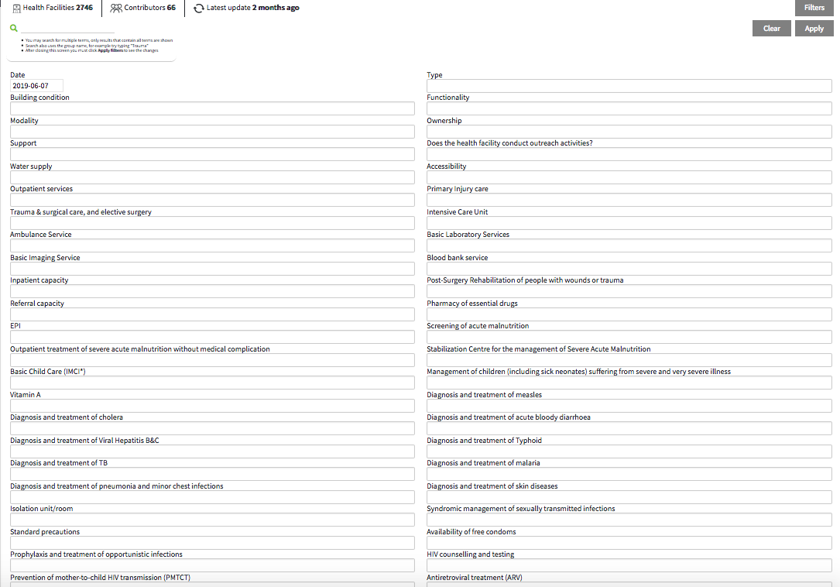

# Projects & Workspaces

The following sections will guide users on how to manage HeRAMS projects and user’s workspaces. It also describes the roles of the HeRAMS users.

## **Managing Projects & Workspaces**

Please follow the steps below to access HeRAMS projects by implementing country, and navigate through the actions that could be done per project.

| Step | Action | Result |
| --- | --- | --- |
| 1 | ../../Screen%20Shot%202019-04-12%20at%2012.32.32.pngClick on  To display the admin dashboard, which includes two pages:   * Projects * Backend administration   The total number of HeRAMS projects managed at the platform is displayed at the lower left corner of the screen | ../../Screen%20Shot%202019-04-12%20at%2012.18.25.png |
| 2 | Click on Projects and a list of countries implementing HeRAMS will be displayed, together with the total number of Workspaces assigned per country, and their authorized actions  Click on ../../Screen%20Shot%202019-05-01%20at%2011.47.22.pngto display the dashboard of the selected project  Click on ../../Screen%20Shot%202019-05-01%20at%2011.47.51.png to edit the attributes of a selected project. This is accessible for Admins level permission’s only  Click on ../../Screen%20Shot%202019-05-01%20at%2011.47.58.png to share the selected project with a user; either Allow access to the project dashboard from the world map, or Allows full access to all workspaces in this project, depends on your level of rights | ../../Screen%20Shot%202019-04-18%20at%2013.42.55.png |
| 3 | Click on ../../Screen%20Shot%202019-05-01%20at%2011.47.44.png of a selected country project to display the list of workspaces related to that project | ../../Screen%20Shot%202019-04-17%20at%2023.16.15.png |
| 4 | Based on your permission, you can manage a selected workspace through these actions  **Of note:**  Users must be careful when updating their data. If users want to keep the historical records and create new records for the up-to-date data, they MUST use “Update” button, while if users want to overwrite the existing record and update its data, they MUST use “Edit” button. | | Button | Definition | | --- | --- | |  | **Update:**  To change the title and/or the owner of the WS.  Note:   * The token remains the same; it is displayed but it can’t be changed. * The first name and last name field options in the tokens will be overridden upon project WS creation | |  | **Data update:**  To register a new facility, or update the existing data as follows:   * **View;** click on this button to view the existing record. * **Edit;** click on this button to overwrite the current record and remove the historical data. * **Update**; click on this button to create a new record and keep the historical data. By clicking this button, the following message will appear: You are about to create a new record for this facility, keeping it's previous record in the history trail. If you wish to edit this record (and erase the previous information) use the edit function instead. If not, proceed. * **Delete**; click on this button to erase the data record. | |  | **Share:**  Share the workspace with users with a certain level of permissions (e.g., read/write)  ../../Screen%20Shot%202019-04-17%20at%2023.29.54.png | |  | **Download**:  Download data in .CSV format, and select your preference of answers (as text or code). | | ../../Screen%20Shot%202019-04-17%20at%2023.26.11.png | **Delete**:  Delete this workspace | |

# 

## **HeRAMS Users’ roles**

HeRAMS users are grouped under the following roles:

1. **Workspace (WS) owner:** manages generally one (occasionally several) WSs. Typically connects and
2. Goes to a given project/WSs
3. Consumes data from the dashboards/exports reports, etc
4. Shares access to those WSs with other users and generally manages access to the WSs he/she is in charge of
5. **Data contributor:** doesn't own a WS but has been granted access to contribute data to the process. Typically connects and
6. Goes directly to a given project/WS
7. Consumes data from the dashboards/exports reports, etc
8. Goes to his/her WS (typically 1 per contributor) and works on data (data edit function linking him/her to the response table and various edit/update functions)
9. **Data viewer:** is granted access to WS(s) (read-only mode)
10. Goes directly to a given project/WS
11. Consumes data from the dashboards/exports reports, data, etc
12. Views detailed data from the WS(s) he/she has been granted access to
13. **Data consumer**
14. Goes directly to a given project
15. Consumes data from the dashboards/exports reports, etc
16. Doesn’t have access to WSs (but may go to the list of WSs and request extended permissions to become Data viewer, Data contributor, etc.)

# Additional Features

* **User’s Profile:**

To update your personal information, please click on your name in the top right part of the screen, and edit the details as needed

* **Logout:**

To logout of the platform, click on the arrow ../../Screen%20Shot%202019-06-12%20at%2001.06.47.png in the top right part of the screen

1. The Modality of Service Delivery (MoSD) is the means through which services are being delivered. MoSDs are in most cases health facilities, but also include emergency specific modalities such as field hospitals, mobile clinics or emergency response teams.